Rotary Foundation  Newsletter | 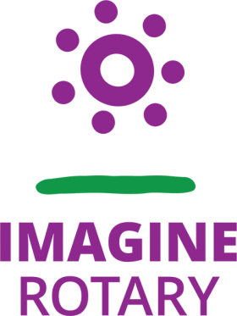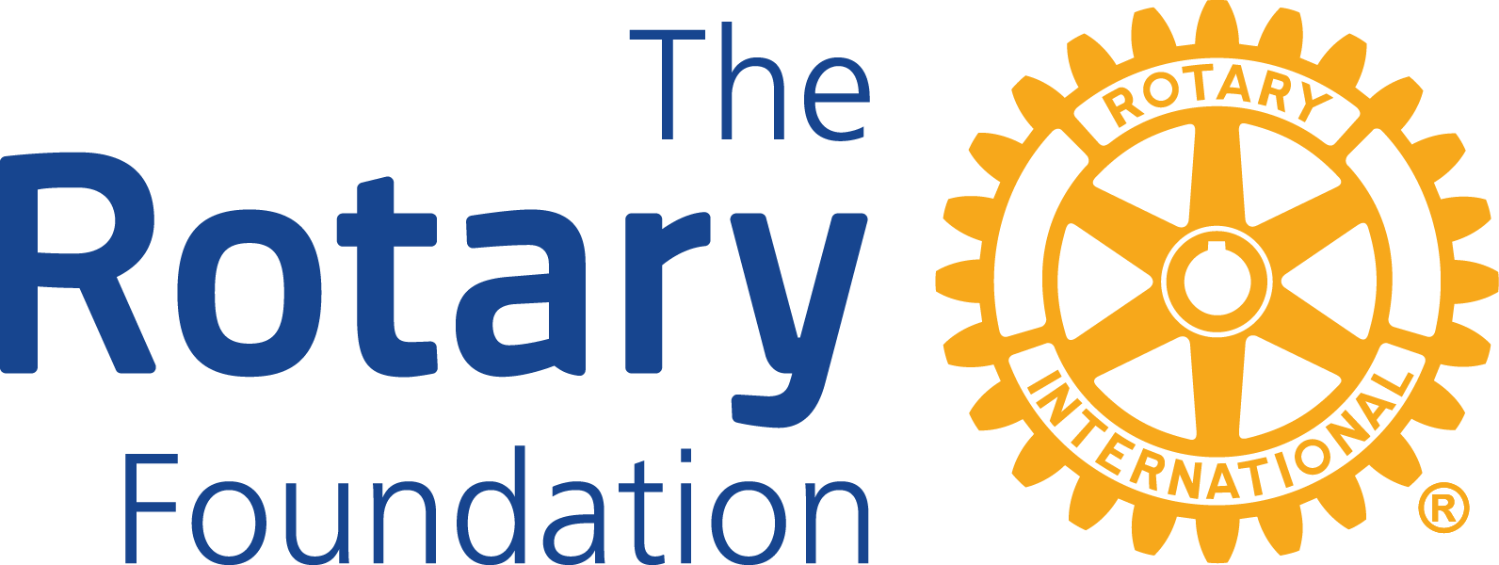  Marilyn’s Brief  Marilyn Stevens has just returned from Conference in Canberra where her "Why" I belong to Rotary was spelt out loud & clear.  - They heard from John Hewko our R.I. Secretary General who resides in Evanston USA but is Ukrainian. He talked about how our Foundation is helping a war ravaged country, and how each District is having a real impact. Globally Rotary has donated approximately USD$35m. to Ukraine, $15 million of that from our Foundation. This money has purchased generators for areas where the power has been taken out, ambulances, medical ids and equipment, mattresses, daily needs  - A young woman from the Philippines won a Peace Scholarship. She has been working in areas of significant social deprivation and with gang members She will now go and study at a university to get her degree in Peacekeeping!  - A little girl is a recipient of medical aid through ROMAC, birth weight 2lb 4oz, with a tumour on her spine the same size. ROMAC arranged for her and her mother to go from Tonga to Canberra for life saving surgery. She is the first recipient of this service since Covid when the gates were closed. Now 4 months old, she is receiving chemotherapy  - The MC is a Polio Survivor, he wears shorts so people can see his legs in callipers and is seen talking here with the man who started his climb up Mt Everest where he was going to paraglide down, all for the sake of polio eradication., Watch the movie which is coming out for Polio Day.  We have our own global grants active in New Zealand, district 9910 for mental health - the money doesn't always go overseas.

- Giving to the Foundation
If all the members in our District were able to give a minimum of NZ$100 through their club, on our current membership would have donated $121,400. To June 2022 we have donated $95,630 to the Annual and Polio Plus Funds.
- Marilyn Stevens (and others) have just returned from a Conference in Canberra where her “Why I belong to Rotary” was spelt out loud and clear
- Our District is working with Finland to directly help people in the Ukraine
Tonga - Improving orthopedic surgery
- Rotary Te Tai Tokerau Tamariki Mental Wellbeing Project
- District Grants - who, why and how
- The Cadre of Technical Advisors
- Support in the District to help your club support its communities

And more

Giving to the Foundation  This newsletter is not about how much we put into the Foundation, this is about the value we create for our own communities and across the globe.  For the 2021-22 Rotary year 8 Clubs achieved the goal of donating at least NZ$100 per member to the Annual Programs Fund (APF) compared to 16 the previous year and 7 the year before that. Giving to APF is important as it provides us with 50% in 3 years’ time for our district and global grant projects.  There is a schedule of giving by Clubs to APF over the past four years to 30 June 2022 which only includes donations that were made through the D9940 Foundation account. (As this is a large excel document, I have added it as an attachment)  The contributions of three clubs who gave $9,000 between them missed the deadline for those contributions to be included in the 2021-2022 Rotary year. This is a timely reminder that it is important for Clubs to get their contributions deposited in the D9940 Foundation Account by the 31 May deadline to ensure they are counted in that Rotary year.  If you are planning to make a contribution but find you are unable to meet that deadline please  communicate with either Martin Garcia or Peter Whittington as early as possible.  So far for this Rotary year, contributions to the Foundation in the first quarter of this Rotary year are usually reasonably light however comparisons are $17,673 received to date compared to $7,300 last year | .  We have welcomed one new Paul Harris Society (PHS) member this year. PHS members commit to giving US1,000 per annum while they can and receive a certificate and chevron pin indicating their commitment. Please contact Martin for more information should you wish to join others in our District who are making this commitment.  We appreciate the encouragement of Area Governors for members to become Centurion Club members – NZ$100 per annum ($150 if possible due to the tax refund). Several clubs now have all members giving at this level and Centurion contributions in 2021-22 amounted to NZ$18,500. Due to a large number of Wellington members donating through their club and to the significant efforts of Graeme Prince with the Whanganui Clubs our current Centurion membership is 190 members. Graeme’s achievements are an inspiration to area networks and Clubs to achieve a significant increase in Centurion Club members. Please ask Graeme, Peter, or Martin if you require assistance.    Thank you also for your fundraising efforts to end polio. Special thanks are due to Chris Tchernegovski and his team for organising the steam train ride to end polio, Awapuni Rotary for organising fundraising through a miniature railway, the many Port Nicholson and other Rotarians who were involved in the bacon butty event at Wellington Railway Station, and Peter Whittington for his wine sales which have now topped $600 in contributions to end polio in just a few weeks.  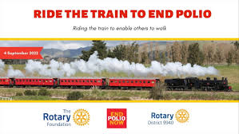  Finally, a reminder that donations to help the work of Rotarians in the world should be remitted through the Rotary District 9940 Foundation bank account 03-0502-0416962-00.
Ukraine, Finland and District 9940 in New Zealand

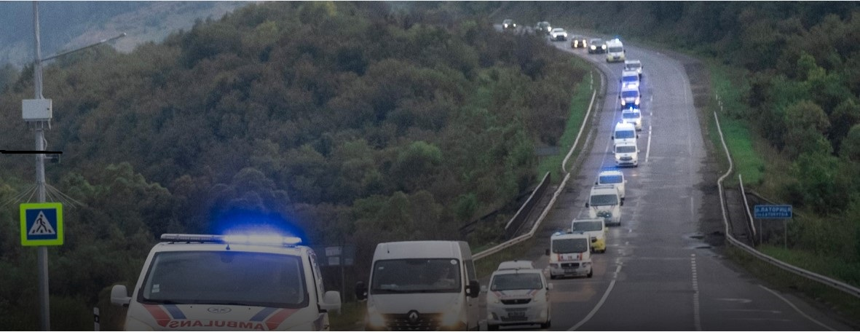

Finnish Rotarians will drive ambulances into Ukraine

In June 2022, Rotary Hutt Valley held a ‘Big Hats, High Tea’ function and sold Thermal Gift Bags containing thermal drink bottle, chocolates, a NZ Life and Leisure magazine and planted a native tree on behalf of all purchasers, to raise funds to support the resettlement of Ukraine refugees in Lahti, Finland D1390. The Big Hats and High Tea function and Gift Bag sales were widely supported by many D9940 clubs, Rotarians, friends, and families.

Following the function, and with the additional support of a Rotary Foundation District Grant, $15,000 was sent to D1390 for medical, food, accommodation, and educational needs. PDG Judy Bain D9940 liaising with PDG Veli Heinijoki Finland District 1390 ensured total funds raised were used solely to aid resettlement of Ukrainian families. Rotary Hutt Valley and D9940 funding was hugely appreciated by both D1390 and the Ukrainian refugees.

Earlier this year, The Rotary Foundation called for donations to help provide people affected by the war in Ukraine with essential items such as water, food, shelter, medicine, and clothing. Several of our Clubs donated and The Rotary Foundation raised more than US$15 million which it is dispersing through Disaster Response Grants.

Very recently IPDG Eila Parvianien, D1390 Finland sent a request asking for D9940 to join in an application for a USD50,000 Disaster Response Grant to provide field ambulances and medical equipment to Ukraine. DG Marilyn Stevens and TRF Chair Martin Garcia were instrumental in supporting this application. We have now been advised that our application has been successful. Once the vehicles have been adapted for service as a field ambulance Finnish Rotarians will drive these ambulances to Ukraine.

Both these projects highlight the benefit of Rotarians across the oceans working collaboratively to achieve hugely successful outcomes.

Judy Bain (PDG)
Rotary Hutt Valley

The Rotary International website has an interesting article on all the support for Ukraine which can be found here

Tongan Orthopedic Surgical Project
The Rotary Club of Wanganui North is working to upgrade the orthopedic surgical services at Vaiola Hospital in Nuku’alofa, Tonga.
The Rotary Club of Wanganui North have been working on its Tongan Orthopedic Surgical Project for the past three years. Their goal is to upgrade the orthopedic surgical services at Vaiola Hospital in Nuku’alofa, Tonga. This has long been the vision of John Van Dalen, a member of the Club and a well-known Whanganui Orthopedic Surgeon.
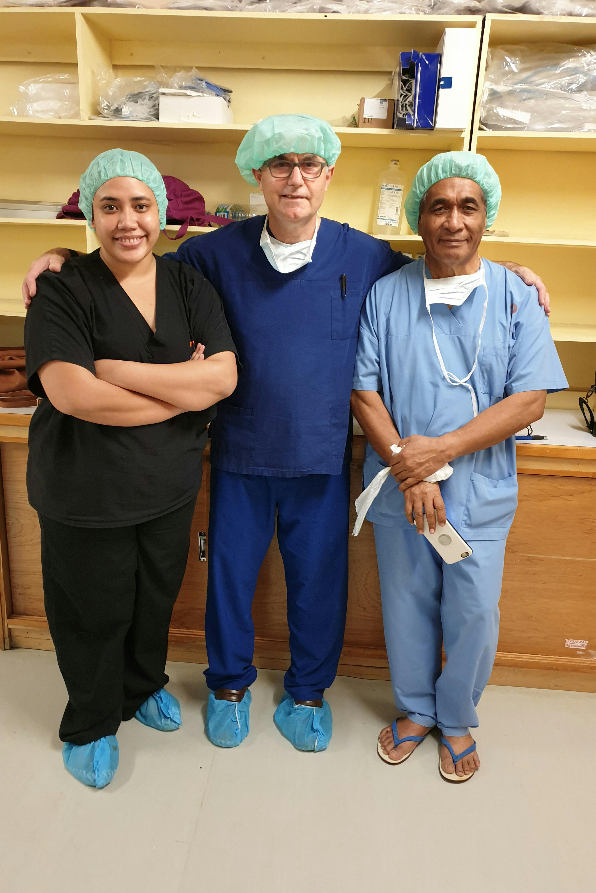
The total value of their Tonga Project is $120,000. The project is fully funded by a Rotary Foundation Global Grant and a New Zealand Aid Grant, along with support from Rotary Wanganui North, Rotary Whanganui and other Rotary Clubs in New Zealand and overseas.
Dr Bill Tangi, (Head Surgeon – right.
Dr John van Dalen Visiting NZ Surgeon – centre
and trainee surgeon Doctor Marina Tuinukuafeo (left

On 29 August Vaiola Hospital received the latest shipment of orthopedic surgical equipment organised by Rotary Whanganui North. The 8 boxes, with the value of NZ$ 30,000, were shipped by the overseas supplier (the market value being 4 to 5 x times greater).
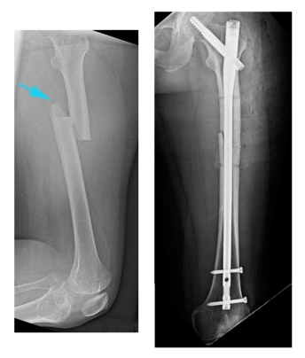
These x-rays show a broken thigh bone on the left, with modern day intra medullary rod fixation of the fracture on the right. The outdated technique of traction for six weeks to treat such fractures, which has till recently been used in Tonga, will now be supplanted by more modern-day fixation techniques.
This has been made possible through the acquisition of a trauma table donated by Whanganui hospital (in 2019) and equipment (2022), as well as the input from visiting surgeons. The purchase of equipment has come about through generous donations from NZ Aid, Rotary Foundation and Whanganui North Rotary club.
Arrangements are being made to provide the medical team at Vaiola Hospital with ongoing training in orthopedic surgery. Training of a resident Tongan surgeon, to come to Whanganui, New Zealand to upskill in fracture management, is being arranged for 2023/24. Rotary Wanganui North estimate the Project will take another two to three years to complete.
Original article by Rtn Tony Hodge, Rotary Club of Wanganui North, International & Medical Projects Committee
If you or your club is interested in further information or getting involved with this project, please contact Tony

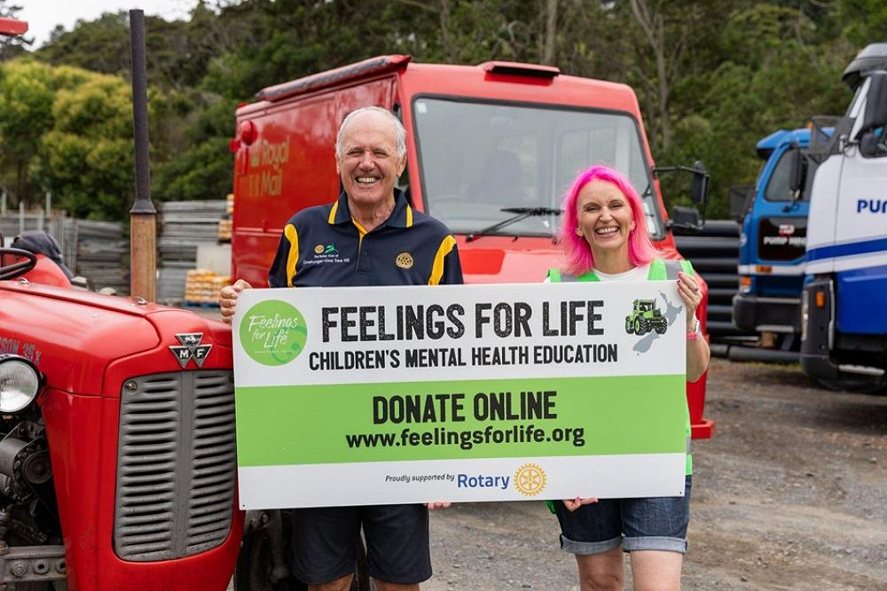  GLOBAL GRANT TO ADDRESS THE SILENT EPIDEMIC AFFECTING NEW ZEALAND’S YOUNG  This article has been condensed from an original article written by Bernadette Horrell, District & Disaster Response Grant Officer, Rotary International South Pacific and Philippines Office (RISPPO), Sydney  The full article originally published in the RISPPO Regional Bulletin March 2022 and excerpts reprinted with the permission of Grace Ramirez, Manager, International Office, and Financial Services, RISPPO  Your Club can make a sustainable difference to the lives of people in your communities  - Is your Club making a significant and enduring difference for your communities?  - Do you have a significant need in one of the communities you serve that would benefit from access to funding and skills?  - Is that community need in one of the Rotary Foundation’s areas of focus?  - You could have the basis for a global grant project with funding available from the Rotary Foundation.  Global grants support projects of more than US$30,000 in one or more of the Rotary Foundation’s areas of focus and must be carried out in partnership with a Rotary Club or District in another country. This may mean, for example, that you could attract significant funds to a project carried out by your Club in New Zealand or in another country.  If you have identified a significant community need:  - Talk to a member of your District Foundation team  - Read A Guide to Global Grants for detailed information on planning your project, applying for a grant to fund it, carrying it out, and reporting on your progress and outcome.  - Examine the Global Grants Community Assessment Results form to help clarify the community’s needs.  - Read the relevant area of focus guidelines for global grant funding. These are the updated guidelines for Clubs who want to apply for a global grant from The Rotary Foundation to support activities in:  - Peacebuilding and conflict prevention  - Disease prevention and treatment  - Water, sanitation, and hygiene  - Maternal and child health  - Basic education and literacy  - Community economic development  - Environment  Have you heard of:  The Rotary Foundation’s Cadre of Technical Advisors  Have you ever considered developing a project funded by a global grant from The Rotary Foundation? If so, there's a TRF resource available called the Cadre of Technical Advisors that could help you get started! The Cadre is a group of Rotarian volunteers with expertise in Rotary's areas of focus, global grants, and auditing. Cadre members support the design of global grant projects as well as perform site visits and audits of funded projects. Check out more information Cadre of Technical Advisers | My Rotary  My partner Derek and I are both Cadre members, and we'd love to help you design a global grant that will meet TRF requirements such as conducting a community assessment, ensuring fit to an area of focus and sustainability, and developing a monitoring plan. My expertise is in Community Economic Development and I serve as one of 3 CED Technical Coordinators on the Cadre's leadership team. Derek's expertise is in Disease Prevention and Treatment as well as Maternal and Child Health. If you have questions about global grants and the areas of focus, we'd be happy to help. Reach out via email at emblingc@yahoo.com.  Candace Bangura  Rotary Club of Port Nicholson  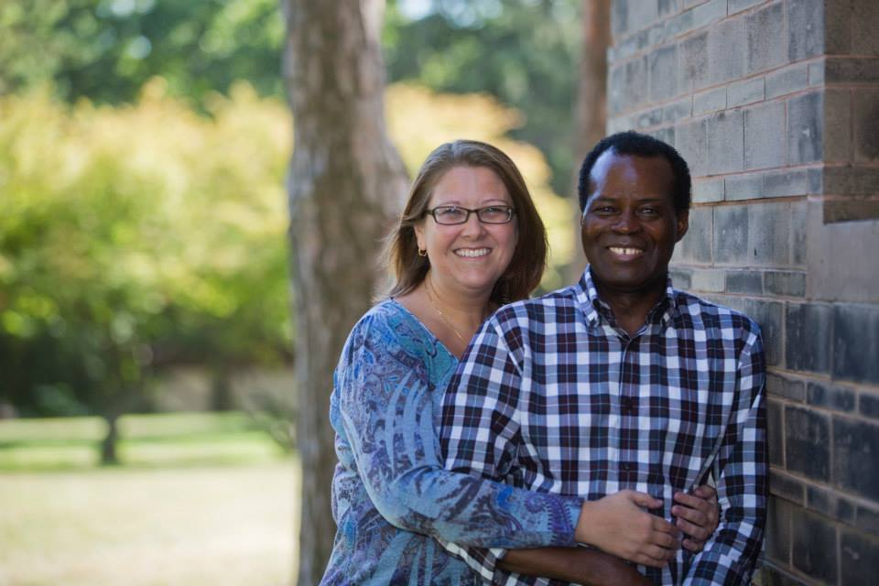  “Miriam Mylvaganam is an international development expert who is passionate about improving the lives of vulnerable communities around the world.  Following her qualification in Development Studies and International Relations, she worked for a non-profit organisation which supported projects led by partner organisations across 20 countries. This led to her being central to the relocation of the organisation’s headquarters across Thailand and Cambodia, establishing key operations there During the COVID-19 response, Miriam went on to lead the coordination efforts for refugees to enter and stay in New Zealand’s Managed Isolation and Quarantine system. The leading of these operations soon expanded into leading the MIQ phase for the Afghanistan Emergency Response.  Following her work at MIQ, Miriam went on to work for Immigration New Zealand. She worked for Refugee Services, and now works in the International Strategy team where she provides strategic direction on the governance of the Migration Five forum which New Zealand is the Permanent Secretariat for.  As a first-generation New Zealander, Miriam brings the diversity and understanding of other cultures and thrives in a multi-cultural context. Her voluntary experience has been spent within New Zealand, as well as across Cambodia, Thailand, Vietnam, and Malawi.  Miriam is also passionate about social justice, human rights and mental health. In her spare time, she pursues her interests in singing, art and interior design.  She is a big believer in supporting businesses with an ethical cause and believes everyone has the ability to make a difference and contribute to peace and development in our world today.”  Rotary Foundation stories straight from My.rotary.org  Want to learn more about Rotary's history and milestones? Visit our timeline.  Listen to our latest podcast episode: "Outsmarting polio", featuring Carol Pandak, director of PolioPlus for Rotary International, and Dr. Ananda Bandyopadhyay, deputy director of polio team at the Bill & Melinda Gates Foundation.  Rotary and the Bill & Melinda Gates Foundation extends fundraising partnership to eradicate polio. Read more.  The Rotary International Board of Directors and Rotary Foundation Trustees release a position statement on COVID-19 vaccination  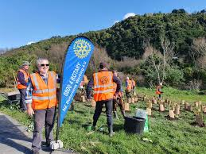  Rotary Club of Hutt Valley  “Rotarians at Work” |  |  | Rotary Te Tai Tokerau Tamariki Mental Wellbeing Project  A silent epidemic is having a devastating impact on New Zealand’s young. Thousands of young people are affected by mental health issues – anxiety, depression, or ADHD. One in four Kiwi kids will experience a mental health issue before the age of 18, fifty percent by the age of 12. It took one woman with an idea and Rotary to provide a lifeline.  Mental health issues are particularly prevalent in Northland and this is where District 9910’s Global Grant will be initiated. The Project will be spread over three years. The first year lays the groundwork with the design of training content and materials, bookings, setting objectives, and hypotheses. Cat has packaged her popular brand of school presentations into a learning program that is available online and in person. This program will provide others with the tools used to recognize and address emotional issues in children. Training will begin in the second year, with 450 teachers and 60 schools already signed up. The training will teach them how to use Cognitive Behavioural Therapy (CBT) and Acceptance & Commitment Therapy (ACT) to assist young people to deal with anxiety, anger, and emotional regulation.  During the third year, training will continue in more schools, and academic research will measure the impact on the community. By end of school year 2024, the program will have connected with 9,000 primary school pupils and will have provided them with the knowledge to ‘change what you think’. Teachers and countless care providers will be given a mental health toolbox to create a sustainable mental well-being program. Once established its success will attract support and funding from Government.  This project is sustainable as the information can be freely shared among teaching staff and parents. If successful, the Rotary Te Tai Tokerau Tamariki Mental Wellbeing Project will be rolled out throughout the country. It is an inspired idea that, with the support of Rotary, will improve children’s’ mental health by providing them with the tools they need to address issues and help them to meet their full potential. The Rotary Foundation Global Grant will assist Cat to take her “Think and Be Me” program to all schools in Northland.  District Foundation Team  - Martin Garcia -Tawa  (District 9940 Foundation Chair)  - Peter Whittington - Port Nicholson  (Rotary Foundation and Centurion Administrator)  - Graeme Prince – Wanganui North  (Fundraising)  - Adrienne Murray – Porirua  (Public Image)  - Andy Watson - Marton  (Vocational Training Teams)  - Chris Tchernegovski - Kāpiti  (End Polio and Polio Plus Promotion)  - Dave Appleyard – Hutt Valley  (District Scholarships and Fellowships)  - Juliette Darnley – Levin  (District Grants)  - Dr Derek and Candace Bangura – Port Nicholson (members of the Cadre of Technical Advisors)  - DGN Jocelyn Hogg – Levin  (Stewardship Committee)  - Ex-officio members –  DG Marilyn Stevens and DGE Wayne Gordon.  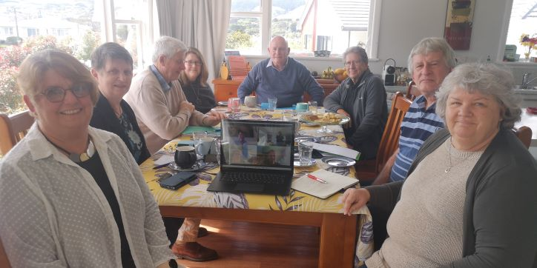  The team at work one sunny Sunday morning  Or  Our District’s New Peace Fellow  Each year, Rotary awards up to 130 fully funded fellowships for dedicated leaders from around the world to study at one of its seven peace centres. Earlier this year we endorsed Miriam Mylvaganam of the Hutt Valley for a Rotary peace fellowship. Last week we were excited to hear that Miriam has been accepted to study at the University of Bradford from September 2023 to December 2024.  Miriam was selected from over 600 endorsed applications worldwide. We are very excited for her and the ongoing involvement we will share through Rotary. Miriam’s sponsor club in New Zealand is the Rotary Club of Hutt Valley which is the club of our Peace Fellowship Chair Dave Appleyard. Thanks are due to Dave, his predecessor Marion Eades, and PDG Gillian Jones who all interviewed Miriam and guided her through the process.  The University of Bradford Rotary Peace Centre hosts and supports ten Rotary Peace Fellows from around the world each year. Miriam will study Masters degree courses that examine issues such as peace, conflict, security and development locally and globally.  We wish Miriam all the very best with her studies    ROTARY AND THE FIGHT AGAINST POLIO  Whilst Polio was discovered as a disease that killed and maimed hundreds of people in the early 1900’s Rotary International began its fight against polio with a multiyear project to immunize 6 million children in the Philippines in 1979  In 1985 RI launched PolioPlus with an initial fundraising target of US$120m. 10 years later health workers and volunteers immunized 165m children in India and China in 1 week.  Rotarians from our District were amongst those who went to India  Until 2 years ago Polio had reduced to only 2 known cases; and now the level is back at 29 across several countries including USA and UK. “We cannot afford to take our foot off the pedal!  And now - the annual appeal for PolioPlus in our District takes place across almost all our Clubs and as a District initiative.  Your continued support for this very important international project is very welcome.    Last but not least  District Grants  District Grants awarded by the Rotary Foundation for District 9940 for the 2022 – 23 year  US$15,240 was available for the grants  - Applications are due by 30 May each year  - There is a standard form which is available in the document library on the district website  - Juliette Darnley is our District Grants Chair  - It can take up to 2 months to get grants approved through the district and then the Foundation  - If your application does not meet the Foundation criteria it cannot be approved  - If your application is not approved, we will let you know why  - Applications forwarded to the Foundation are reviewed by the DG, the District Foundation Chair and the District Grants Chair  - We will endeavour to help you frame your application so it can be approved BUT it must meet the Foundation criteria  - The amount of money available is DIRECTLY linked to the Foundation giving by the district, and the money available has been steadily reducing  - End of Project report MUST be completed so we can report back to the Foundation.  - The next year’s grants cannot be approved without this being completed  If you are interested in finding out about the specifics of any of these projects don’t hesitate to contact Juliette (Levin) or any of the clubs directly
 | District/Club | Description |  | Amount (USD)
 | Awapuni | New Kiwi Club, supporting young refugees in after school groups to be better integrated into NZ. Rotarians work with the after-school groups as well as providing support to the teachers |  | 625
 | Awapuni | Plant2plate: teaching young children to grow vegetables and then how to cook them. Rotarians involved in the gardens and in the schools |  | 625
 | Awapuni | Starlight: helping to support children in hospital and mental health facilities, fundraise for care packages, collect, sort, pack and distribute, spending time with the children |  | 1250
 | Hutt Valley | Fundraising, liaise with Finland District 1390 support Ukraine refugees, medical, food, accommodation and educational needs |  | 3125
 | Kapiti | RYLA Kapiti is the organising club and these funds will help support the costs |  | 3125
 | Levin | Tamariki Sleep Well Project - providing packs containing pj's, hygiene products, a book and knitted slippers & hat to at risk children |  | 750
 | Ngāmotu, Taranaki | Alzheimers, provide 10 6-seater dining and/or activity tables. Also volunteers at the day care facility |  | 1875
 | Plimmerton | Clothing for pre-schoolers in low socio-economic groups, Rotarians are working on the design of this program, fundraising, selected the clothing and taking it to the preschool groups/kindergartens |  | 2500
 | Tawa | Refurbishment of Information Board at the entrance of Mexted Reserve. Working with a number of partners, design the new board, erect it and beautification around the entrance to the reserve |  | 625

