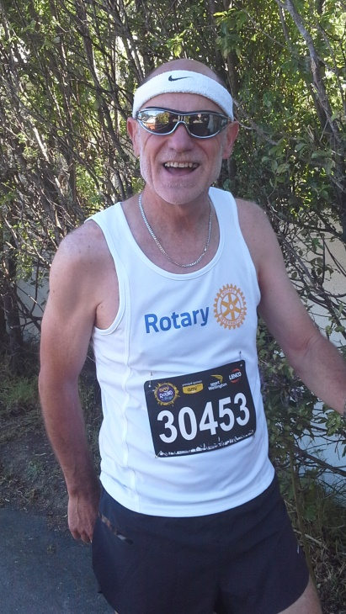
F R F R
( Fair Replacement Fun Run )
Sponsor Lionel on the ‘November 2021 Queenstown Half Marathon’
$20 … (target $1000)
All funds to Wellington North Rotary Club Charitable Trust Fund
Pay to: Club account 03 0518 0023645 000 … by 12 December
Please indicate if receipt wanted for tax purposes.
Reference: FRFR and your name
Through this generous sponsorship you are helping the Wellington North Rotary Club recover lost income from the cancelled Khandallah Fair.
Thank you

